Percentage Operations

Percentage of numbers
# Source: AI Source: Provided by: [Data Path: Persons Table -> ID Column: 1, Name_En Column: Motasem Essam] -> From: [ChatGPT] on [7/15/2026]
Percentage of a Number is the process of finding a specified part of a whole number using a percentage. It answers questions such as "What is 25% of 80?" or "Find 12% of 250."
Finding percentages of numbers is a fundamental arithmetic skill used in finance, business, statistics, science, engineering, shopping, taxation, and everyday life.

Definition
# Source: AI Source: Provided by: [Data Path: Persons Table -> ID Column: 1, Name_En Column: Motasem Essam] -> From: [ChatGPT] on [7/15/2026]
A percentage of a number is the value obtained by taking a certain number of parts out of every 100 parts of that number.
For example,
- 50% of a number means one-half of the number.
- 25% means one-quarter.
- 10% means one-tenth.

Percentage Formula
# Source: AI Source: Provided by: [Data Path: Persons Table -> ID Column: 1, Name_En Column: Motasem Essam] -> From: [ChatGPT] on [7/15/2026]
To find a percentage of a number, use
$$\boxed{\text{Part}=\frac{\text{Percentage}}{100}×\text{Whole}}$$

Visualizing the Relationship
# Source: AI Source: Provided by: [Data Path: Persons Table -> ID Column: 1, Name_En Column: Motasem Essam] -> From: [ChatGPT] on [7/15/2026]
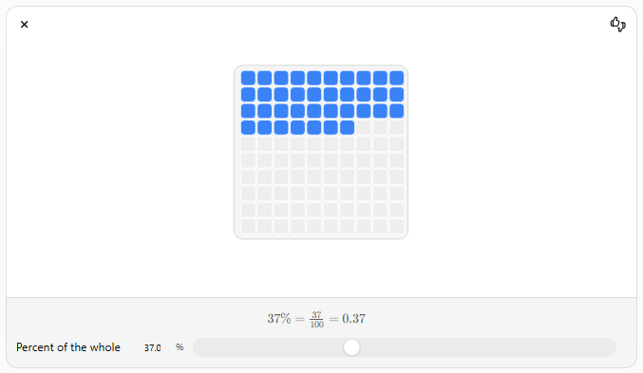
The percentage determines what fraction of the whole is taken.

Steps to Find a Percentage of a Number
# Source: AI Source: Provided by: [Data Path: Persons Table -> ID Column: 1, Name_En Column: Motasem Essam] -> From: [ChatGPT] on [7/15/2026]
Step 1
Convert the percentage to a decimal or fraction.

Step 2
Multiply by the whole number.

Step 3
Simplify the result if necessary.

Method 1: Convert the Percentage to a Fraction
# Source: AI Source: Provided by: [Data Path: Persons Table -> ID Column: 1, Name_En Column: Motasem Essam] -> From: [ChatGPT] on [7/15/2026]
Example
Find
$$25\%$$
of
$$80$$
Convert
$$25\%=\frac{25}{100}=\frac{1}{4}$$
Multiply
$$\frac{1}{4}×80=20$$
Answer:
$$25\%\text{ of }80=20$$

Example
Find
$$75\%$$
of
$$40 \\ \frac{75}{100}=\frac{3}{4} \\ \frac{3}{4}×40=30$$

Method 2: Convert the Percentage to a Decimal
# Source: AI Source: Provided by: [Data Path: Persons Table -> ID Column: 1, Name_En Column: Motasem Essam] -> From: [ChatGPT] on [7/15/2026]
Example
Find
$$12\%$$
of
$$250$$
Convert
$$12\%=0.12$$
Multiply
$$0.12×250=30$$

Example
Find
$$8\%$$
of
$$450 \\ 0.08×450=36$$

Common Percentage Values
# Source: AI Source: Provided by: [Data Path: Persons Table -> ID Column: 1, Name_En Column: Motasem Essam] -> From: [ChatGPT] on [7/15/2026]
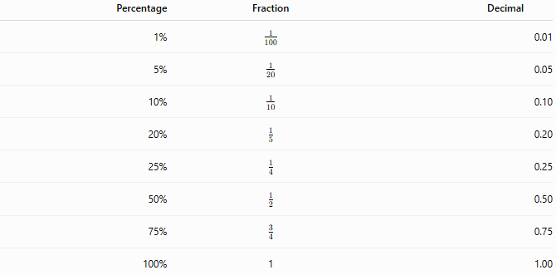
Percentage | Fraction | Decimal
1% | $$\frac{1}{100}$$ | 0.01
5% | $$\frac{1}{20}$$ | 0.05
10% | $$\frac{1}{10}$$ | 0.10
20% | $$\frac{1}{5}$$ | 0.20
25% | $$\frac{1}{4}$$ | 0.25
50% | $$\frac{1}{2}$$ | 0.50
75% | $$\frac{3}{4}$$ | 0.75
100% | 1 | 1.00

Finding More Than 100%
# Source: AI Source: Provided by: [Data Path: Persons Table -> ID Column: 1, Name_En Column: Motasem Essam] -> From: [ChatGPT] on [7/15/2026]
Percentages may exceed
$$100\%.$$

Example
Find
$$150\%$$
of
$$40 \\ 1.5×40=60$$

Example
Find
$$250\%$$
of
$$24 \\ 2.5×24=60$$

Finding Negative Percentages
# Source: AI Source: Provided by: [Data Path: Persons Table -> ID Column: 1, Name_En Column: Motasem Essam] -> From: [ChatGPT] on [7/15/2026]
Negative percentages represent decreases or negative quantities.

Example
Find
$$-20\%$$
of
$$150 \\ -0.20×150=-30$$

Examples
# Source: AI Source: Provided by: [Data Path: Persons Table -> ID Column: 1, Name_En Column: Motasem Essam] -> From: [ChatGPT] on [7/15/2026]
Example 1
Find
$$10\%$$
of
$$90 \\ 0.10×90=9$$

Example 2
Find
$$15\%$$
of
$$200 \\ 0.15×200=30$$

Example 3
Find
$$40\%$$
of
$$75 \\ 0.40×75=30$$

Example 4
Find
$$60\%$$
of
$$150 \\ 0.60×150=90$$

Example 5
Find
$$125\%$$
of
$$48 \\ 1.25×48=60$$

Example 6
Find
$$2.5\%$$
of
$$320 \\ 0.025×320=8$$

Applications
# Source: AI Source: Provided by: [Data Path: Persons Table -> ID Column: 1, Name_En Column: Motasem Essam] -> From: [ChatGPT] on [7/15/2026]
Finding percentages of numbers is used in:
- Arithmetic
- Algebra
- Statistics
- Finance
- Economics
- Engineering
- Science
- Business
- Accounting
- Computer Science

Real-Life Applications
# Source: AI Source: Provided by: [Data Path: Persons Table -> ID Column: 1, Name_En Column: Motasem Essam] -> From: [ChatGPT] on [7/15/2026]
Finding percentages of numbers is used in:
- Shopping discounts
- Sales tax
- Interest calculations
- Exam grades
- Business profits
- Investment returns
- Population studies
- Medical statistics
- Manufacturing quality control
- Scientific research

Real-Life Examples
# Source: AI Source: Provided by: [Data Path: Persons Table -> ID Column: 1, Name_En Column: Motasem Essam] -> From: [ChatGPT] on [7/15/2026]
1. Shopping Discount
A jacket costs
$$\$120$$
and is discounted by
$$25\%.$$
Discount:
$$0.25×120=\$30$$

2. Sales Tax
A product costs
$$\$80$$
with a
$$15\%$$
tax.
Tax:
$$0.15×80=\$12$$

3. Exam Score
A student answers
$$45$$
out of
$$50$$
questions correctly.
Correct answers:
$$90\%$$
of
$$50=45$$

4. Bank Interest
A savings account contains
$$\$1000$$
and earns
$$6\%$$
interest.
Interest:
$$0.06×1000=\$60$$

5. Manufacturing
If
$$3\%$$
of
$$2000$$
products are defective,
Defective products:
$$0.03×2000=60$$

6. Population Study
If
$$18\%$$
of
$$5000$$
people prefer a product,
Number of people:
$$0.18×5000=900$$

Common Mistakes
# Source: AI Source: Provided by: [Data Path: Persons Table -> ID Column: 1, Name_En Column: Motasem Essam] -> From: [ChatGPT] on [7/15/2026]
- Forgetting to divide the percentage by
$$100.$$
- Multiplying by the whole number before converting the percentage.
- Confusing
$$25\%$$
with
$$25.$$
- Forgetting that percentages greater than
$$100\%$$
are possible.
- Rounding too early during calculations.

Key Points
# Source: AI Source: Provided by: [Data Path: Persons Table -> ID Column: 1, Name_En Column: Motasem Essam] -> From: [ChatGPT] on [7/15/2026]
- Convert the percentage to a decimal or fraction.
- Multiply by the whole number.
- Percent means "per hundred."
- Percentages may be less than, equal to, or greater than
$$100\%.$$
- The result represents the specified part of the whole number.

Percentage of a Number vs. Percentage Conversion
# Source: AI Source: Provided by: [Data Path: Persons Table -> ID Column: 1, Name_En Column: Motasem Essam] -> From: [ChatGPT] on [7/15/2026]
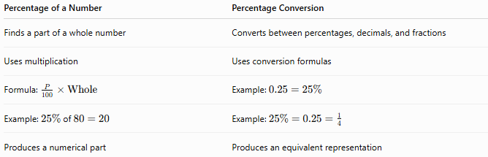
Percentage of a Number | Percentage Conversion
Finds a part of a whole number | Converts between percentages, decimals, and fractions
Uses multiplication | Uses conversion formulas
Formula: $\frac{P}{100}×\text{Whole}$ | Example: $0.25=25\%$
Example: $25\%$of $80=20$ | Example: $25\%=0.25=\frac{1}{4}$
Produces a numerical part | Produces an equivalent representation

Conclusion
# Source: AI Source: Provided by: [Data Path: Persons Table -> ID Column: 1, Name_En Column: Motasem Essam] -> From: [ChatGPT] on [7/15/2026]
Percentage of a Number is the process of finding a specified fraction of a whole number using a percentage. This is done by converting the percentage to a decimal or fraction and multiplying it by the whole number. Mastering this concept is essential for arithmetic, finance, business, engineering, science, statistics, and many everyday calculations involving discounts, taxes, interest, grades, probabilities, and data analysis.

Percentage Increase
# Source: AI Source: Provided by: [Data Path: Persons Table -> ID Column: 1, Name_En Column: Motasem Essam] -> From: [ChatGPT] on [7/15/2026]
Percentage Increase is the process of measuring how much a quantity has grown relative to its original value. It expresses the increase as a percentage of the original amount.
Percentage increase is widely used in arithmetic, finance, economics, business, engineering, science, statistics, and everyday life.

Definition
# Source: AI Source: Provided by: [Data Path: Persons Table -> ID Column: 1, Name_En Column: Motasem Essam] -> From: [ChatGPT] on [7/15/2026]
A percentage increase represents the amount by which a value increases, expressed as a percentage of the original value.
It answers questions such as:
- By what percentage did the price increase?
- What is the percentage growth?
- How much did the population increase?
- What is the percentage gain?

Percentage Increase Formula
# Source: AI Source: Provided by: [Data Path: Persons Table -> ID Column: 1, Name_En Column: Motasem Essam] -> From: [ChatGPT] on [7/15/2026]
The percentage increase is calculated using
$$\boxed{\text{Percentage Increase}=\frac{\text{New Value}-\text{Original Value}}{\text{Original Value}}×100\%}$$
where
- Original Value is the starting value.
- New Value is the final value.

Finding the New Value After an Increase
# Source: AI Source: Provided by: [Data Path: Persons Table -> ID Column: 1, Name_En Column: Motasem Essam] -> From: [ChatGPT] on [7/15/2026]
If the percentage increase is already known, the new value is
$$\boxed{\text{New Value}=\text{Original Value}×\left(1 + \frac{P}{100}\right)}$$
where $P$is the percentage increase.

Visualizing the Relationship
# Source: AI Source: Provided by: [Data Path: Persons Table -> ID Column: 1, Name_En Column: Motasem Essam] -> From: [ChatGPT] on [7/15/2026]
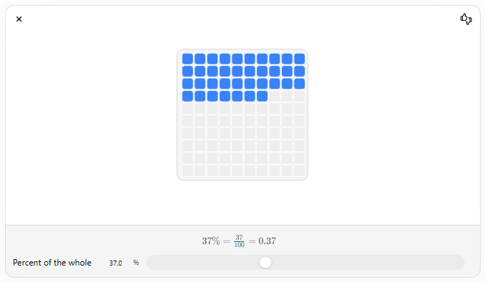
The increase is a part of the original value, and the new value equals the original value plus that increase.

Steps for Finding Percentage Increase
# Source: AI Source: Provided by: [Data Path: Persons Table -> ID Column: 1, Name_En Column: Motasem Essam] -> From: [ChatGPT] on [7/15/2026]
Step 1
Find the increase.
$$\text{Increase}=\text{New}-\text{Original}$$

Step 2
Divide the increase by the original value.

Step 3
Multiply by
$$100\%$$

Steps for Finding the New Value
# Source: AI Source: Provided by: [Data Path: Persons Table -> ID Column: 1, Name_En Column: Motasem Essam] -> From: [ChatGPT] on [7/15/2026]
Step 1
Convert the percentage into a decimal.

Step 2
Add
$$1$$
to the decimal.

Step 3
Multiply by the original value.

Examples
# Source: AI Source: Provided by: [Data Path: Persons Table -> ID Column: 1, Name_En Column: Motasem Essam] -> From: [ChatGPT] on [7/15/2026]
Example 1
A product costs
$$\$80$$
and later costs
$$\$100.$$
Find the percentage increase.
Increase:
$$100-80=20$$
Percentage increase:
$$\frac{20}{80}×100\%=25\%$$

Example 2
A salary increases from
$$\$2000$$
to
$$\$2400.$$
Increase:
$$2400-2000=400$$
Percentage increase:
$$\frac{400}{2000}×100\%=20\%$$

Example 3
A population grows from
$$5000$$
to
$$6500.$$
Increase:
$$1500$$
Percentage increase:
$$\frac{1500}{5000}×100\%=30\%$$

Example 4
A price of
$$\$50$$
increases by
$$12\%.$$
New value:
$$50(1+0.12)=50(1.12)=56$$

Example 5
A quantity of
$$120$$
increases by
$$40\%.$$
New value:
$$120(1.40)=168$$

Example 6
A company's sales increase from
$$750$$
units to
$$900$$
units.
Increase:
$$150$$
Percentage increase:
$$\frac{150}{750}×100\%=20\%$$

Percentage Increase Factors
# Source: AI Source: Provided by: [Data Path: Persons Table -> ID Column: 1, Name_En Column: Motasem Essam] -> From: [ChatGPT] on [7/15/2026]
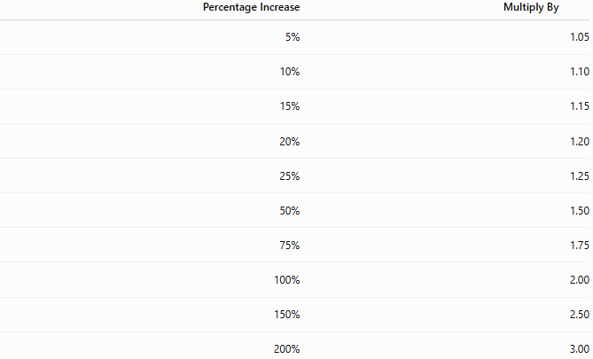
Percentage Increase | Multiply By
5% | 1.05
10% | 1.10
15% | 1.15
20% | 1.20
25% | 1.25
50% | 1.50
75% | 1.75
100% | 2.00
150% | 2.50
200% | 3.00

Applications
# Source: AI Source: Provided by: [Data Path: Persons Table -> ID Column: 1, Name_En Column: Motasem Essam] -> From: [ChatGPT] on [7/15/2026]
Percentage increase is used in:
- Arithmetic
- Finance
- Economics
- Business
- Accounting
- Engineering
- Statistics
- Science
- Data Analysis
- Computer Science

Real-Life Applications
# Source: AI Source: Provided by: [Data Path: Persons Table -> ID Column: 1, Name_En Column: Motasem Essam] -> From: [ChatGPT] on [7/15/2026]
Percentage increase is used in:
- Salary raises
- Product price increases
- Inflation
- Population growth
- Investment returns
- Company profits
- Sales growth
- Tax adjustments
- Manufacturing output
- Scientific measurements

Real-Life Examples
# Source: AI Source: Provided by: [Data Path: Persons Table -> ID Column: 1, Name_En Column: Motasem Essam] -> From: [ChatGPT] on [7/15/2026]
1. Salary Increase
Salary:
$$\$3000$$
Increase:
$$10\%$$
New salary:
$$3000(1.10)=\$3300$$

2. Product Price
Price:
$$\$120$$
Increase:
$$15\%$$
New price:
$$120(1.15)=\$138$$

3. Population Growth
Population:
$$50 000$$
Growth:
$$8\%$$
New population:
$$50 000(1.08)=54 000$$

4. Investment
Investment:
$$\$8000$$
Growth:
$$12\%$$
New value:
$$8000(1.12)=\$8960$$

5. Company Sales
Sales increase from
$$1000$$
to
$$1300$$
Percentage increase:
$$30\%$$

6. Manufacturing
Production increases from
$$600$$
units to
$$720$$
Percentage increase:
$$20\%$$

Common Mistakes
# Source: AI Source: Provided by: [Data Path: Persons Table -> ID Column: 1, Name_En Column: Motasem Essam] -> From: [ChatGPT] on [7/15/2026]
- Dividing by the new value instead of the original value.
- Forgetting to multiply by
$$100\%.$$
- Adding the percentage directly instead of converting it to a decimal.
- Using
$$1-P$$
instead of
$$1+P$$
for an increase.
- Confusing percentage increase with percentage points.

Key Points
# Source: AI Source: Provided by: [Data Path: Persons Table -> ID Column: 1, Name_En Column: Motasem Essam] -> From: [ChatGPT] on [7/15/2026]
- Percentage increase is always based on the original value.
- First find the increase, then divide by the original value.
- To calculate the new value directly, multiply by
$$1+\frac{P}{100}.$$
- Percentage increases can be greater than
$$100\%.$$

Percentage Increase vs. Percentage Decrease
# Source: AI Source: Provided by: [Data Path: Persons Table -> ID Column: 1, Name_En Column: Motasem Essam] -> From: [ChatGPT] on [7/15/2026]
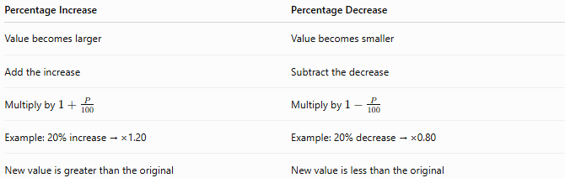
Percentage Increase | Percentage Decrease
Value becomes larger | Value becomes smaller
Add the increase | Subtract the decrease
Multiply by $1+\frac{P}{100}$ | Multiply by $1-\frac{P}{100}$
Example: 20% increase → ×1.20 | Example: 20% decrease → ×0.80
New value is greater than the original | New value is less than the original

Conclusion
# Source: AI Source: Provided by: [Data Path: Persons Table -> ID Column: 1, Name_En Column: Motasem Essam] -> From: [ChatGPT] on [7/15/2026]
Percentage Increase measures how much a value grows relative to its original value and expresses that growth as a percentage. It is calculated by dividing the increase by the original value and multiplying by 100%, or by multiplying the original value by the growth factor $1+\frac{P}{100}$to find the new value directly. Percentage increase is a fundamental concept used in finance, economics, business, engineering, science, and everyday decision-making.

Percentage Decrease
# Source: AI Source: Provided by: [Data Path: Persons Table -> ID Column: 1, Name_En Column: Motasem Essam] -> From: [ChatGPT] on [7/15/2026]
Percentage Decrease is the process of measuring how much a quantity has decreased relative to its original value. It expresses the decrease as a percentage of the original amount.
Percentage decrease is widely used in arithmetic, finance, economics, business, engineering, science, statistics, and everyday life.

Definition
# Source: AI Source: Provided by: [Data Path: Persons Table -> ID Column: 1, Name_En Column: Motasem Essam] -> From: [ChatGPT] on [7/15/2026]
A percentage decrease represents the amount by which a value decreases, expressed as a percentage of the original value.
It answers questions such as:
- By what percentage did the price decrease?
- What is the percentage reduction?
- How much did the population decrease?
- What is the percentage loss?

Percentage Decrease Formula
# Source: AI Source: Provided by: [Data Path: Persons Table -> ID Column: 1, Name_En Column: Motasem Essam] -> From: [ChatGPT] on [7/15/2026]
The percentage decrease is calculated using
$$\boxed{\text{Percentage Decrease}=\frac{\text{Original Value}-\text{New Value}}{\text{Original Value}}×100\%}$$
where
- Original Value is the starting value.
- New Value is the final value after the decrease.

Finding the New Value After a Decrease
# Source: AI Source: Provided by: [Data Path: Persons Table -> ID Column: 1, Name_En Column: Motasem Essam] -> From: [ChatGPT] on [7/15/2026]
If the percentage decrease is already known, the new value is
$$\boxed{\text{New Value}=\text{Original Value}×\left(1 − \frac{P}{100}\right)}$$
where $P$is the percentage decrease.

Visualizing the Relationship
# Source: AI Source: Provided by: [Data Path: Persons Table -> ID Column: 1, Name_En Column: Motasem Essam] -> From: [ChatGPT] on [7/15/2026]
For a single decrease, the new value equals the original value minus the percentage removed. The same multiplication idea extends naturally to successive percentage changes.

Steps for Finding Percentage Decrease
# Source: AI Source: Provided by: [Data Path: Persons Table -> ID Column: 1, Name_En Column: Motasem Essam] -> From: [ChatGPT] on [7/15/2026]
Step 1
Find the decrease.
$$\text{Decrease}=\text{Original}-\text{New}$$

Step 2
Divide the decrease by the original value.

Step 3
Multiply by
$$100\%$$

Steps for Finding the New Value
# Source: AI Source: Provided by: [Data Path: Persons Table -> ID Column: 1, Name_En Column: Motasem Essam] -> From: [ChatGPT] on [7/15/2026]
Step 1
Convert the percentage into a decimal.

Step 2
Subtract the decimal from
$$1.$$

Step 3
Multiply by the original value.

Examples
# Source: AI Source: Provided by: [Data Path: Persons Table -> ID Column: 1, Name_En Column: Motasem Essam] -> From: [ChatGPT] on [7/15/2026]
Example 1
A product costs
$$\$120$$
and later costs
$$\$90.$$
Find the percentage decrease.
Decrease:
$$120-90=30$$
Percentage decrease:
$$\frac{30}{120}×100\%=25\%$$

Example 2
A salary decreases from
$$\$2500$$
to
$$\$2250.$$
Decrease:
$$250$$
Percentage decrease:
$$\frac{250}{2500}×100\%=10\%$$

Example 3
A town's population decreases from
$$8000$$
to
$$7200.$$
Decrease:
$$800$$
Percentage decrease:
$$\frac{800}{8000}×100\%=10\%$$

Example 4
A price of
$$\$80$$
decreases by
$$15\%.$$
New value:
$$80(1-0.15)=80(0.85)=68$$

Example 5
A quantity of
$$250$$
decreases by
$$20\%.$$
New value:
$$250(0.80)=200$$

Example 6
A company's sales decrease from
$$900$$
units to
$$675$$
units.
Decrease:
$$225$$
Percentage decrease:
$$\frac{225}{900}×100\%=25\%$$

Percentage Decrease Factors
# Source: AI Source: Provided by: [Data Path: Persons Table -> ID Column: 1, Name_En Column: Motasem Essam] -> From: [ChatGPT] on [7/15/2026]
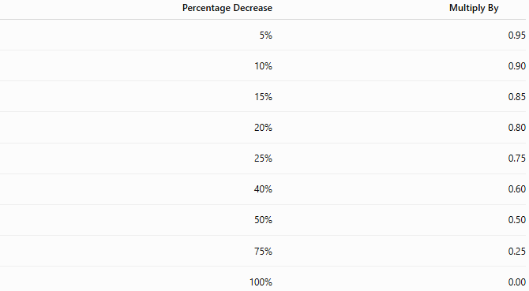
Percentage Decrease | Multiply By
5% | 0.95
10% | 0.90
15% | 0.85
20% | 0.80
25% | 0.75
40% | 0.60
50% | 0.50
75% | 0.25
100% | 0.00

Applications
# Source: AI Source: Provided by: [Data Path: Persons Table -> ID Column: 1, Name_En Column: Motasem Essam] -> From: [ChatGPT] on [7/15/2026]
Percentage decrease is used in:
- Arithmetic
- Finance
- Economics
- Business
- Accounting
- Engineering
- Statistics
- Science
- Data Analysis
- Computer Science

Real-Life Applications
# Source: AI Source: Provided by: [Data Path: Persons Table -> ID Column: 1, Name_En Column: Motasem Essam] -> From: [ChatGPT] on [7/15/2026]
Percentage decrease is used in:
- Store discounts
- Product depreciation
- Salary reductions
- Population decline
- Investment losses
- Company revenue decline
- Fuel consumption reduction
- Tax reductions
- Manufacturing waste reduction
- Scientific measurements

Real-Life Examples
# Source: AI Source: Provided by: [Data Path: Persons Table -> ID Column: 1, Name_En Column: Motasem Essam] -> From: [ChatGPT] on [7/15/2026]
1. Shopping Discount
A jacket costs
$$\$200$$
and is discounted by
$$30\%.$$
New price:
$$200(0.70)=\$140$$

2. Car Depreciation
A car worth
$$\$20 000$$
loses
$$15\%$$
of its value.
New value:
$$20 000(0.85)=\$17 000$$

3. Population Decline
Population:
$$12 000$$
Decrease:
$$5\%$$
New population:
$$12 000(0.95)=11 400$$

4. Investment Loss
Investment:
$$\$5000$$
Loss:
$$8\%$$
New value:
$$5000(0.92)=\$4600$$

5. Manufacturing
Production decreases from
$$1500$$
units to
$$1200$$
units.
Percentage decrease:
$$20\%$$

6. Water Consumption
A household reduces water usage from
$$400$$
liters to
$$300$$
liters.
Percentage decrease:
$$\frac{100}{400}×100\%=25\%$$

Common Mistakes
# Source: AI Source: Provided by: [Data Path: Persons Table -> ID Column: 1, Name_En Column: Motasem Essam] -> From: [ChatGPT] on [7/15/2026]
- Dividing by the new value instead of the original value.
- Forgetting to multiply by
$$100\%.$$
- Using
$$1+P$$
instead of
$$1-P$$
for a decrease.
- Confusing a percentage decrease with the amount decreased.
- Assuming that a percentage decrease followed by the same percentage increase returns to the original value.

Key Points
# Source: AI Source: Provided by: [Data Path: Persons Table -> ID Column: 1, Name_En Column: Motasem Essam] -> From: [ChatGPT] on [7/15/2026]
- Percentage decrease is always based on the original value.
- Find the decrease first, then divide by the original value.
- To calculate the new value directly, multiply by
$$1-\frac{P}{100}.$$
- A 100% decrease reduces the value to zero.
- Percentage decrease and percentage increase are not inverse operations unless they use different percentages based on the new original.

Percentage Decrease vs. Percentage Increase
# Source: AI Source: Provided by: [Data Path: Persons Table -> ID Column: 1, Name_En Column: Motasem Essam] -> From: [ChatGPT] on [7/15/2026]
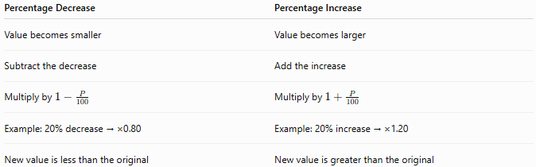
Percentage Decrease | Percentage Increase
Value becomes smaller | Value becomes larger
Subtract the decrease | Add the increase
Multiply by $1-\frac{P}{100}$ | Multiply by $1+\frac{P}{100}$
Example: 20% decrease → ×0.80 | Example: 20% increase → ×1.20
New value is less than the original | New value is greater than the original

Conclusion
# Source: AI Source: Provided by: [Data Path: Persons Table -> ID Column: 1, Name_En Column: Motasem Essam] -> From: [ChatGPT] on [7/15/2026]
Percentage Decrease measures how much a value falls relative to its original value and expresses that reduction as a percentage. It is calculated by dividing the decrease by the original value and multiplying by 100%, or by multiplying the original value by the factor $1-\frac{P}{100}$to find the new value directly. Understanding percentage decrease is essential in finance, business, economics, science, engineering, and many real-world situations involving discounts, depreciation, losses, and reductions.

Percentage Change
# Source: AI Source: Provided by: [Data Path: Persons Table -> ID Column: 1, Name_En Column: Motasem Essam] -> From: [ChatGPT] on [7/15/2026]
Percentage Change is the process of measuring how much a quantity has changed relative to its original value. The change may be an increase or a decrease, and it is expressed as a percentage of the original value.
Percentage change is widely used in arithmetic, finance, economics, business, engineering, science, statistics, and everyday life.

Definition
# Source: AI Source: Provided by: [Data Path: Persons Table -> ID Column: 1, Name_En Column: Motasem Essam] -> From: [ChatGPT] on [7/15/2026]
A percentage change measures the relative difference between an original value and a new value.
It answers questions such as:
- How much has the value changed?
- What is the percentage difference between the old and new values?
- Did the value increase or decrease?
- By what percentage did the quantity change?

Percentage Change Formula
# Source: AI Source: Provided by: [Data Path: Persons Table -> ID Column: 1, Name_En Column: Motasem Essam] -> From: [ChatGPT] on [7/15/2026]
The general formula is
$$\boxed{\text{Percentage Change}=\frac{\text{New Value}-\text{Original Value}}{\text{Original Value}}×100\%}$$
Interpretation:
- Positive result → Percentage Increase
- Negative result → Percentage Decrease
- Zero → No Change

Determining the Type of Change
# Source: AI Source: Provided by: [Data Path: Persons Table -> ID Column: 1, Name_En Column: Motasem Essam] -> From: [ChatGPT] on [7/15/2026]
Result | Meaning
Positive | Percentage Increase
Negative | Percentage Decrease
Zero | No Change

Steps for Finding Percentage Change
# Source: AI Source: Provided by: [Data Path: Persons Table -> ID Column: 1, Name_En Column: Motasem Essam] -> From: [ChatGPT] on [7/15/2026]
Step 1
Find the change.
$$\text{Change}=\text{New Value}-\text{Original Value}$$

Step 2
Divide by the original value.

Step 3
Multiply by
$$100\%.$$

Finding the New Value from Percentage Change
# Source: AI Source: Provided by: [Data Path: Persons Table -> ID Column: 1, Name_En Column: Motasem Essam] -> From: [ChatGPT] on [7/15/2026]
If the percentage change is known,
For an increase:
$$\boxed{\text{New Value}=\text{Original Value}\left(1 + \frac{P}{100}\right)}$$
For a decrease:
$$\boxed{\text{New Value}=\text{Original Value}\left(1 − \frac{P}{100}\right)}$$

Successive Percentage Changes
# Source: AI Source: Provided by: [Data Path: Persons Table -> ID Column: 1, Name_En Column: Motasem Essam] -> From: [ChatGPT] on [7/15/2026]
When two or more percentage changes occur one after another, each percentage is applied to the current value, not the original value.
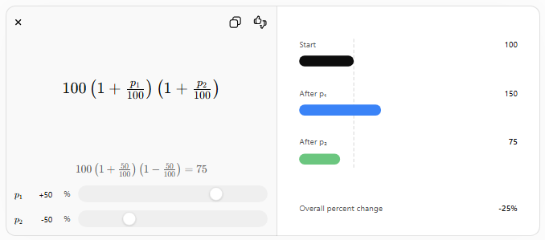
For two successive changes:
$$\boxed{\text{Final Value}=\text{Original Value}\left(1 + \frac{P_{1}}{100}\right)\left(1 + \frac{P_{2}}{100}\right)}$$
If a decrease occurs, replace the corresponding plus sign with a minus sign.

Examples
# Source: AI Source: Provided by: [Data Path: Persons Table -> ID Column: 1, Name_En Column: Motasem Essam] -> From: [ChatGPT] on [7/15/2026]
Example 1 – Percentage Increase
A price increases from
$$\$80$$
to
$$\$100.$$
Change:
$$100-80=20$$
Percentage change:
$$\frac{20}{80}×100\%=25\%$$
Result:
25% Increase

Example 2 – Percentage Decrease
A price decreases from
$$\$150$$
to
$$\$120.$$
Change:
$$120-150=-30$$
Percentage change:
$$\frac{-30}{150}×100\%=-20\%$$
Result:
20% Decrease

Example 3
A salary increases from
$$\$2500$$
to
$$\$2900.$$
Change:
$$400$$
Percentage change:
$$\frac{400}{2500}×100\%=16\%$$

Example 4
Population decreases from
$$6000$$
to
$$5400.$$
Change:
$$-600$$
Percentage change:
$$\frac{-600}{6000}×100\%=-10\%$$
Result:
10% Decrease

Example 5
Stock price rises from
$$\$40$$
to
$$\$50.$$
Percentage change:
$$\frac{10}{40}×100\%=25\%$$

Example 6
Temperature changes from
$${20}^{∘}$$
to
$${20}^{∘}.$$
Percentage change:
$$0\%$$
No change.

Percentage Change vs. Absolute Change
# Source: AI Source: Provided by: [Data Path: Persons Table -> ID Column: 1, Name_En Column: Motasem Essam] -> From: [ChatGPT] on [7/15/2026]
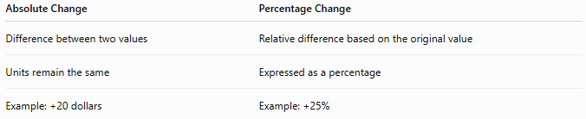
Absolute Change | Percentage Change
Difference between two values | Relative difference based on the original value
Units remain the same | Expressed as a percentage
Example: +20 dollars | Example: +25%

Applications
# Source: AI Source: Provided by: [Data Path: Persons Table -> ID Column: 1, Name_En Column: Motasem Essam] -> From: [ChatGPT] on [7/15/2026]
Percentage change is used in:
- Arithmetic
- Algebra
- Statistics
- Finance
- Economics
- Business
- Accounting
- Engineering
- Science
- Data Analysis

Real-Life Applications
# Source: AI Source: Provided by: [Data Path: Persons Table -> ID Column: 1, Name_En Column: Motasem Essam] -> From: [ChatGPT] on [7/15/2026]
Percentage change is used in:
- Stock market analysis
- Inflation rates
- Population growth
- Business profits
- Sales reports
- Exam performance
- Product pricing
- Manufacturing output
- Scientific experiments
- Economic indicators

Real-Life Examples
# Source: AI Source: Provided by: [Data Path: Persons Table -> ID Column: 1, Name_En Column: Motasem Essam] -> From: [ChatGPT] on [7/15/2026]
1. Product Price
A phone price changes from
$$\$500$$
to
$$\$550.$$
Percentage change:
$$10\%$$
Increase.

2. Fuel Price
Fuel decreases from
$$\$2.50$$
to
$$\$2.20.$$
Percentage change:
$$-12\%$$
Decrease.

3. Exam Scores
A student's score rises from
$$70$$
to
$$84.$$
Percentage change:
$$20\%$$
Increase.

4. Investment
Investment grows from
$$\$8000$$
to
$$\$9200.$$
Percentage change:
$$15\%$$
Increase.

5. Manufacturing
Production decreases from
$$2000$$
units to
$$1800$$
units.
Percentage change:
$$-10\%$$
Decrease.

6. Population
Population grows from
$$25 000$$
to
$$27 500.$$
Percentage change:
$$10\%$$
Increase.

Common Mistakes
# Source: AI Source: Provided by: [Data Path: Persons Table -> ID Column: 1, Name_En Column: Motasem Essam] -> From: [ChatGPT] on [7/15/2026]
- Dividing by the new value instead of the original value.
- Forgetting to multiply by
$$100\%.$$
- Ignoring the sign of the result.
- Confusing percentage change with absolute change.
- Assuming that a 20% increase followed by a 20% decrease returns to the original value (it does not).

Key Points
# Source: AI Source: Provided by: [Data Path: Persons Table -> ID Column: 1, Name_En Column: Motasem Essam] -> From: [ChatGPT] on [7/15/2026]
- Percentage change always uses the original value as the reference.
- A positive result indicates an increase.
- A negative result indicates a decrease.
- Zero indicates no change.
- Percentage change measures relative, not absolute, change.
- Successive percentage changes are applied one after another, not added directly.

Percentage Change vs. Percentage Increase vs. Percentage Decrease
# Source: AI Source: Provided by: [Data Path: Persons Table -> ID Column: 1, Name_En Column: Motasem Essam] -> From: [ChatGPT] on [7/15/2026]
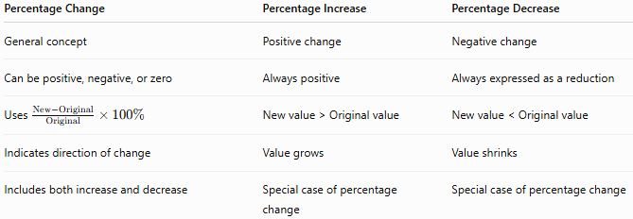
Percentage Change | Percentage Increase | Percentage Decrease
General concept | Positive change | Negative change
Can be positive, negative, or zero | Always positive | Always expressed as a reduction
Uses $\frac{\text{New}-\text{Original}}{\text{Original}}×100\%$ | New value > Original value | New value < Original value
Indicates direction of change | Value grows | Value shrinks
Includes both increase and decrease | Special case of percentage change | Special case of percentage change

Conclusion
# Source: AI Source: Provided by: [Data Path: Persons Table -> ID Column: 1, Name_En Column: Motasem Essam] -> From: [ChatGPT] on [7/15/2026]
Percentage Change measures how much a value has changed relative to its original value, expressing that change as a percentage. A positive percentage indicates an increase, while a negative percentage indicates a decrease. Percentage change is one of the most important concepts in mathematics and is widely used in finance, economics, science, engineering, business, statistics, and everyday decision-making to compare values over time or between different situations.

